

**The University of Lahore**

*Faculty of Information Technology*

|  |
| --- |
| **Assignment Cover Letter**  *(Individual Work)* |

|  |  |  |  |
| --- | --- | --- | --- |
| Student Name | Atta Elahi | Program | BS(SE) |
| SAP ID | 70082385 | Title of Assignment | 02 |
| Course Code | CS 11303 | Due Date | 16/10/2022 |
| Course Name | Operating Systems | Submission Date | 07/11/2022 |
| Section | T |

**The assignment should meet the below requirements:**

1. Assignment (hard copy) is required to be submitted on clean paper and soft copy as per lecturer’s instructions.
2. Soft copy assignment also requires the signed (hardcopy) submission of this form, which automatically validates the softcopy submission.
3. The above information is complete and legible.
4. Compiles pages are firmly attached.
5. Assignment has been copied (softcopy & hardcopy) for each student ahead of the submission.

**Plagiarism/Cheating**

The university seriously regards all forms of plagiarism, cheating and collision as academic offenses which may result in severe penalties, including loss/drop of marks, course/class discontinuity and other possible penalties executed by the University.

**Declaration of Originality**

By signing this assignment, I understand, accept and consent to The University of Lahore terms and policies on plagiarism.

I hereby declare that this work represents my own effort, and that all text and code have been written by me and has not been submitted for the use of assessment in another course or class, except where this has been notified and accepted in advance.

|  |  |
| --- | --- |
| *Signature* |  |

**Question 1: Round robin schedulers normally maintain a list of all runnable processes, with each process occurring exactly once in the list. What would happen if a process occurred twice in the list? Can you think of any reason for allowing this?**

If a processor occurs more than once in the round-robin list, then it will get two turns for each pass through the list. One reason for allowing this would be to implement a primitive priority system since the more times it occurs on the list, the higher the percentage of time the CPU will spend on that process.

**Question 2: Most round robin schedulers use a fixed size quantum. Give an argument in favor of a small quantum. Now give an argument in favor of a large quantum.**

An argument against a small time quantum:  Efficiency. A small time quantum requires the timer to generate interrupts with short intervals. Each interrupt causes a context switch, so overhead increases with a larger number of interrupts. An argument for a small time quantum: Response time. A large time quantum will reduce the overhead of context switching since interrupts will be generated with relatively long intervals, hence there will be fewer interrupts. However, a short job will have to wait longer time on the ready queue before it can get to execute on the processor. With a short time quantum, such a short job will finish quicker and produces the result to the end user faster than with a longer time quantum.

**Question 3: Consider the following set of processes, with the length of the CPU-burst time given in milliseconds:**



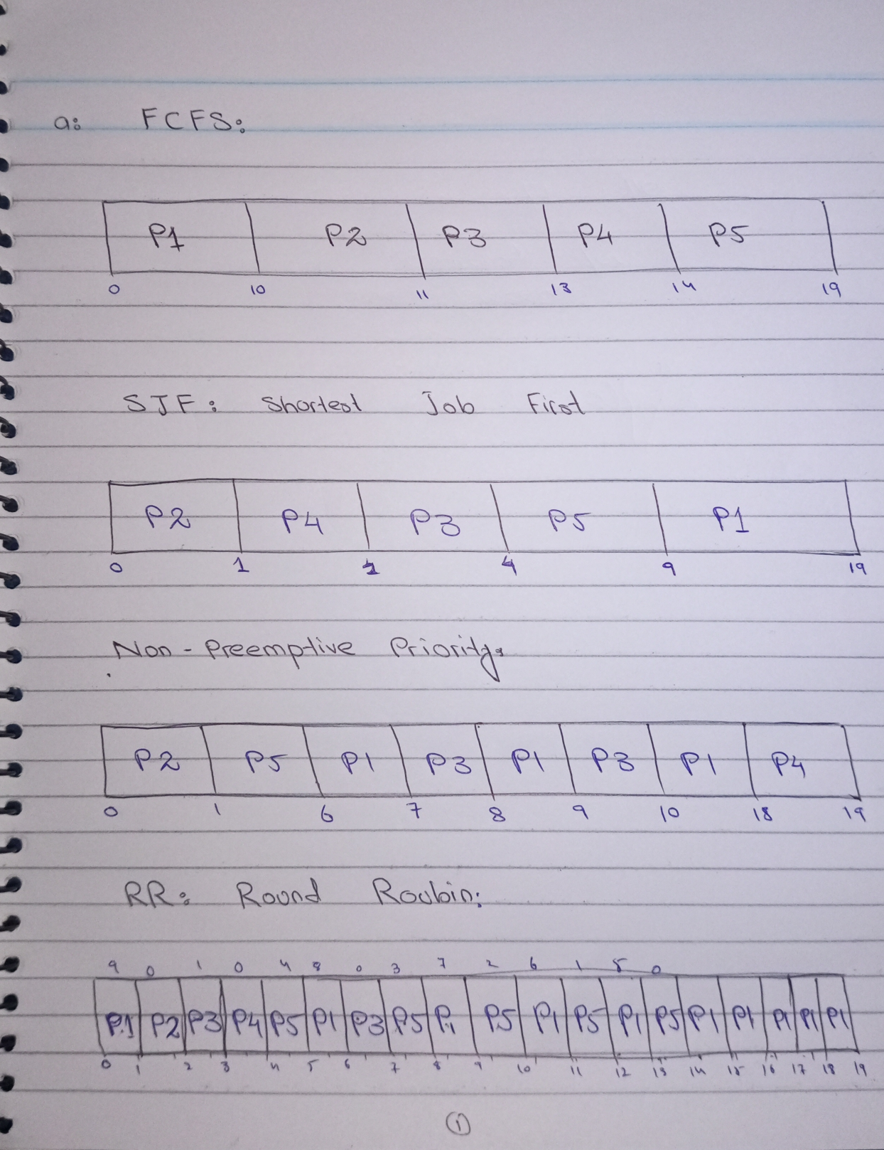

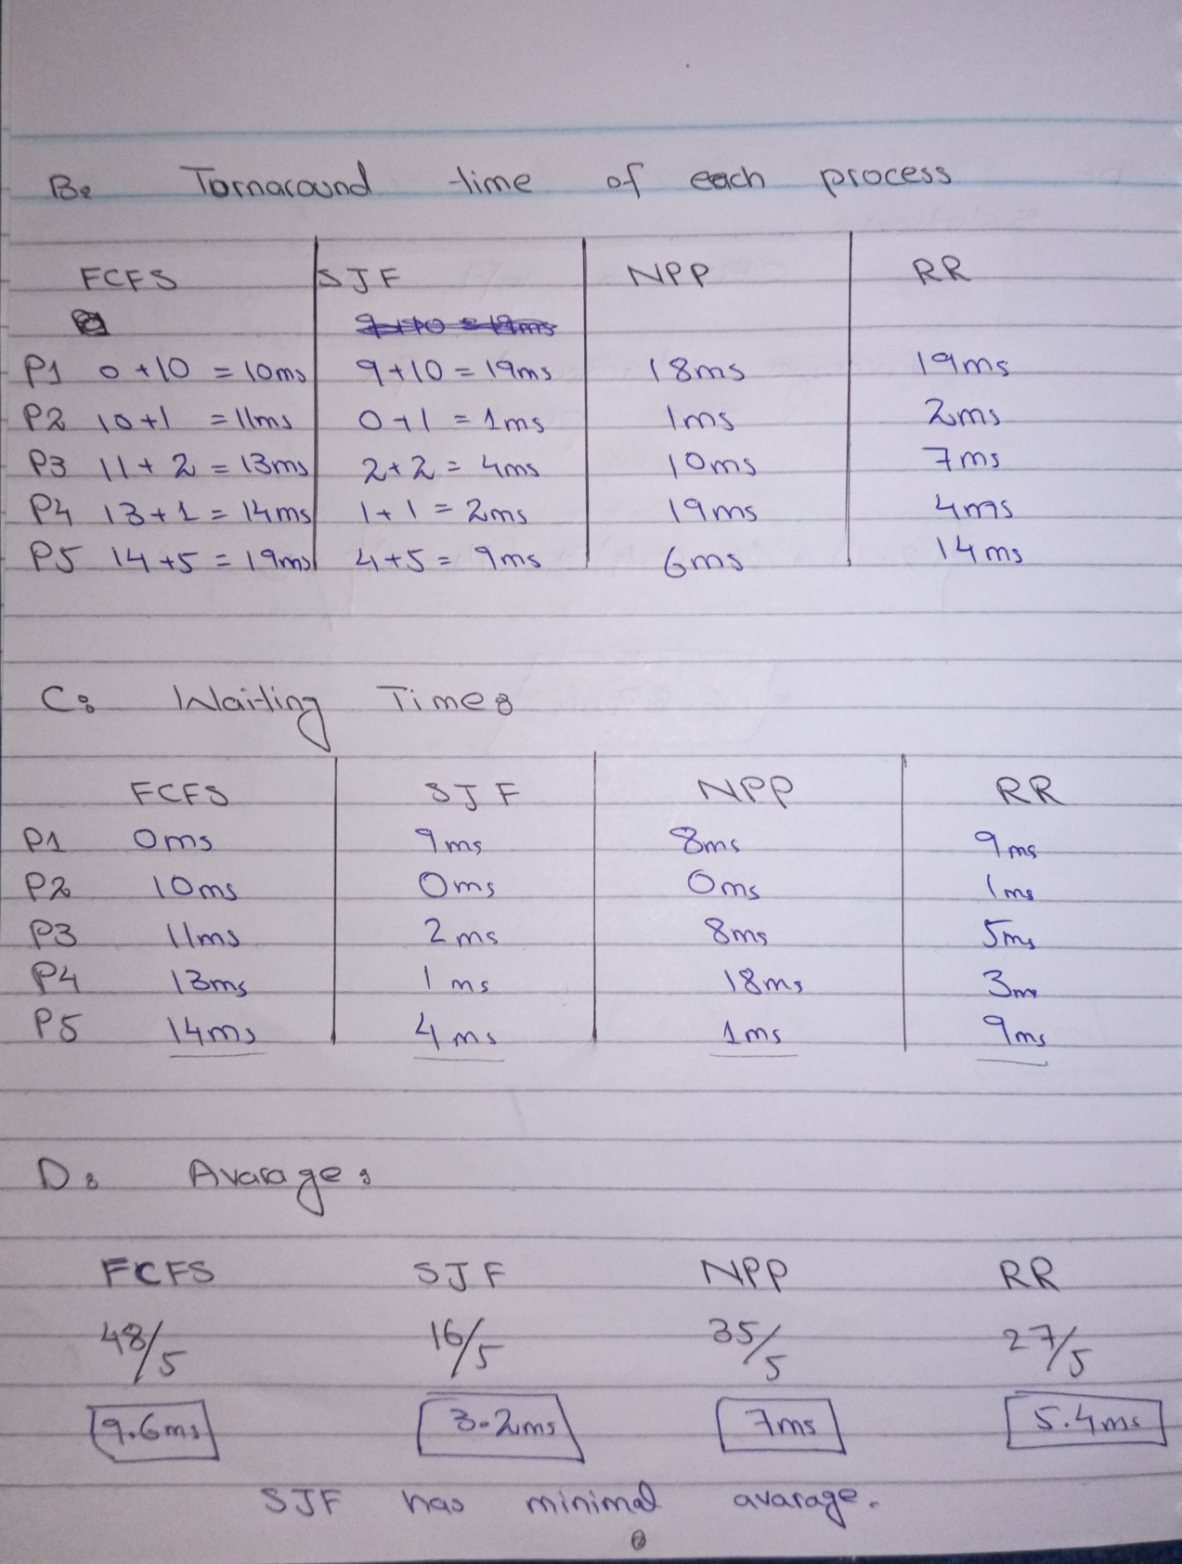

**Question 4: Suppose that the following processes arrive for execution at the times indicated. Each process will run the listed amount of time. In answering the questions, use non-preemptive scheduling and base all decisions on the information you have at the time the decision must be made.**



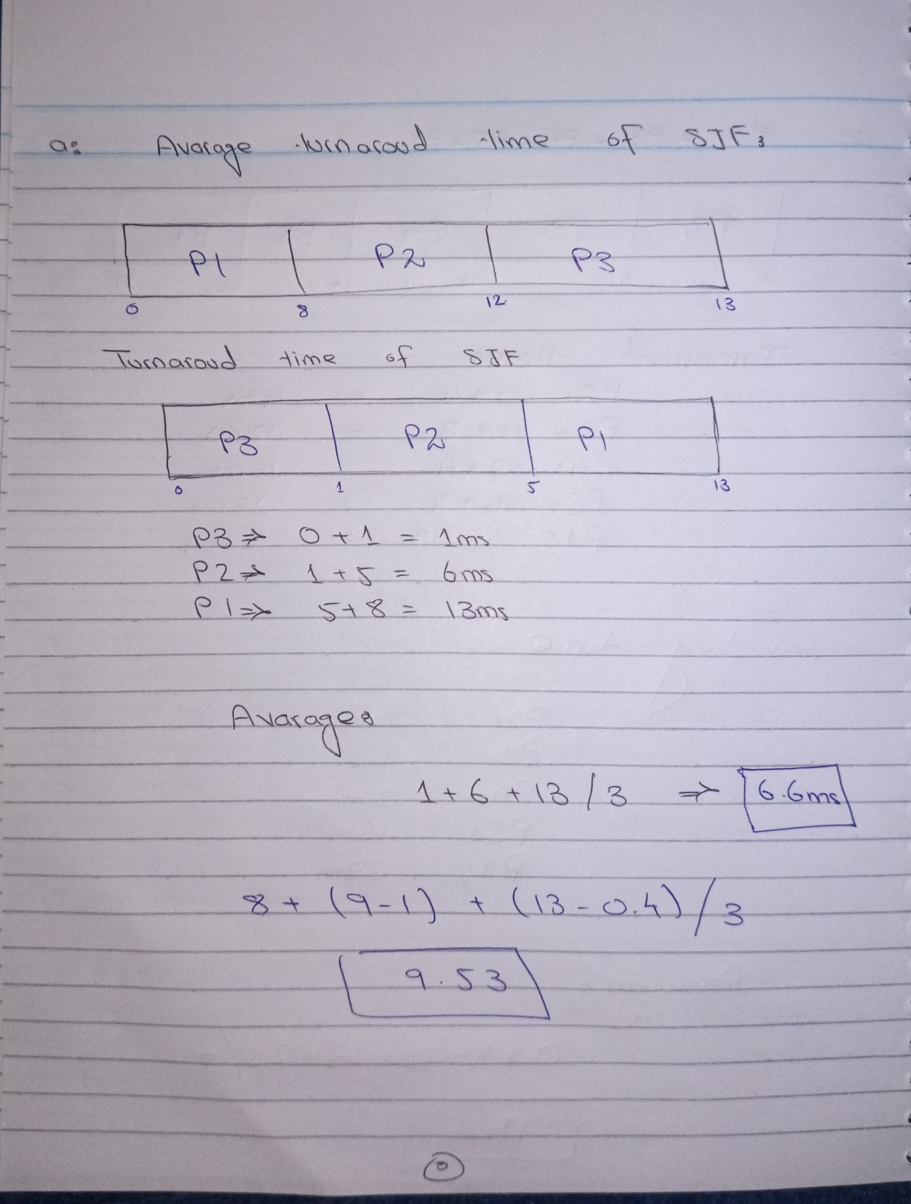

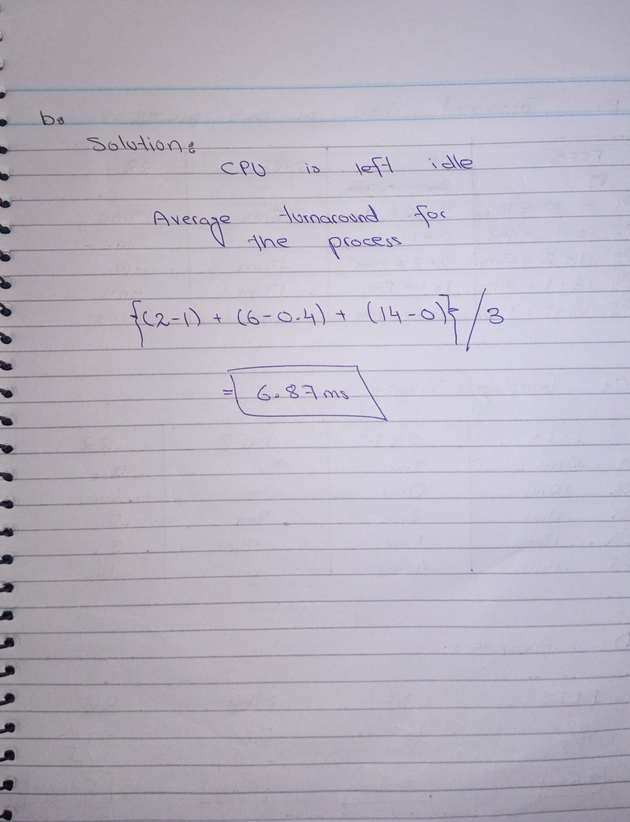

**Question 5: Consider the following set of processes, with the length of the CPU burst given in milliseconds:**

Process Burst

P1 10

P2 4

P3 8

P4 4

P5 7

